Roshan Mykoo

MIU

3/3/2015

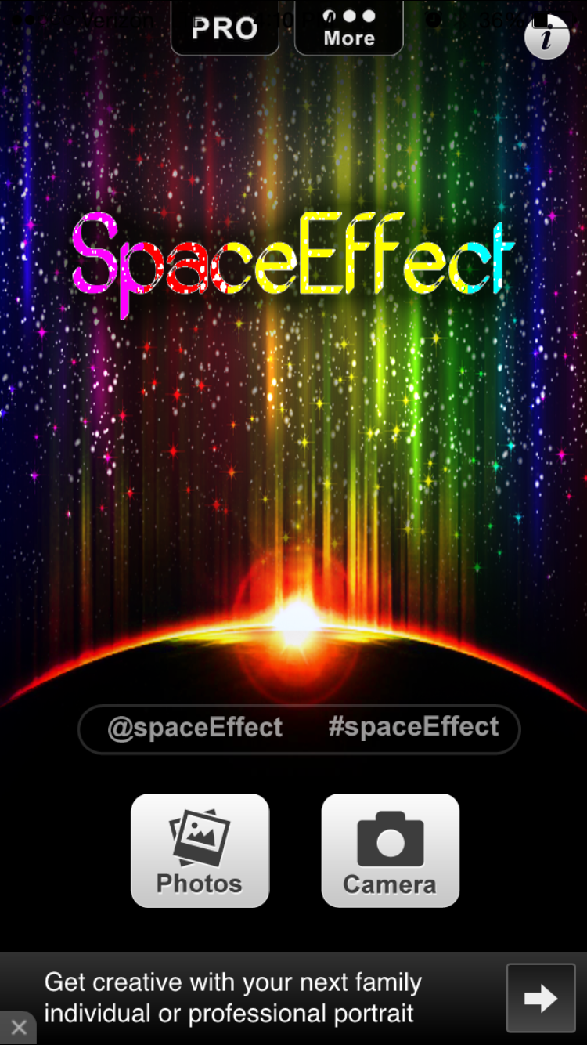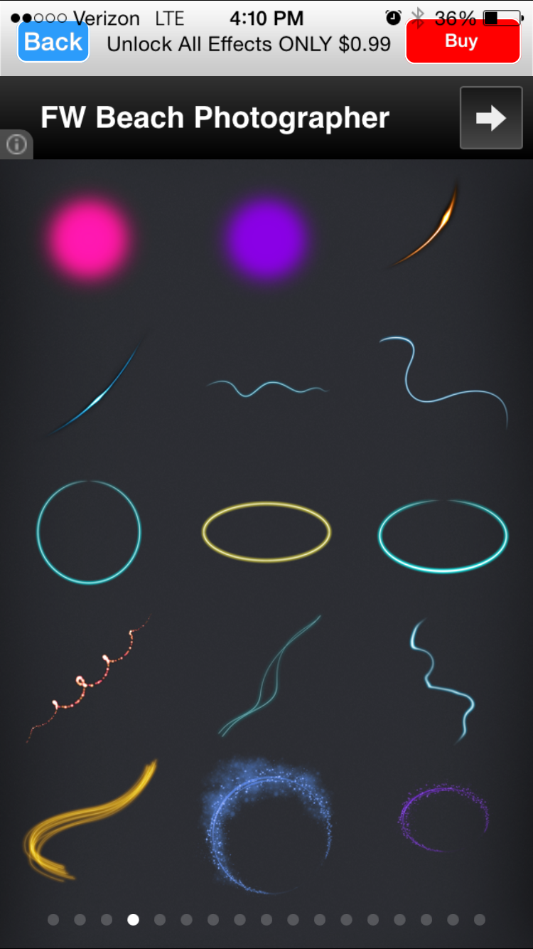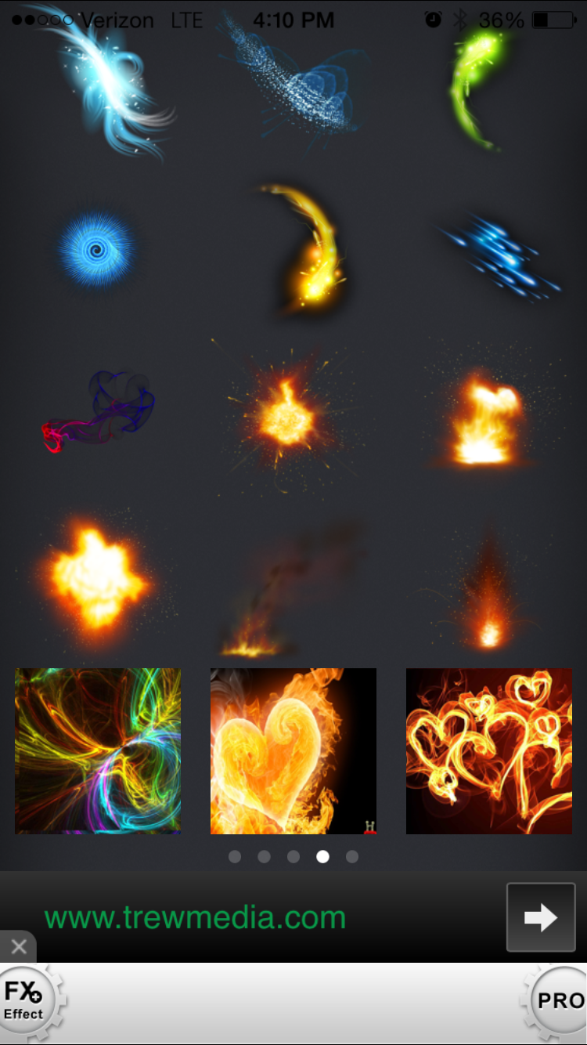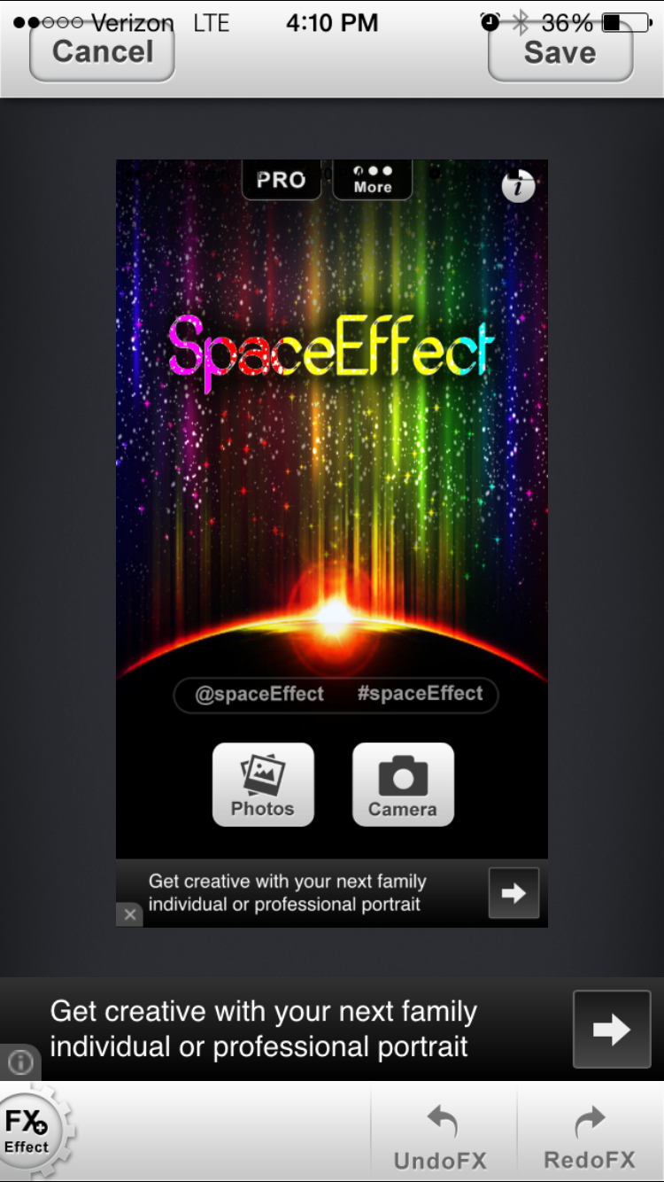

In the SpaceEffectFX PRO App, it allows you to edit photos on your device by adding different pre set render effects to an image. The effect itself can be positioned anywhere on the picture and can be configured to change its rotation or its opacity.